**DAA – Assignment no: 03**

Write a Python program to solve a fractional Knapsack problem using a greedy method.

Input:

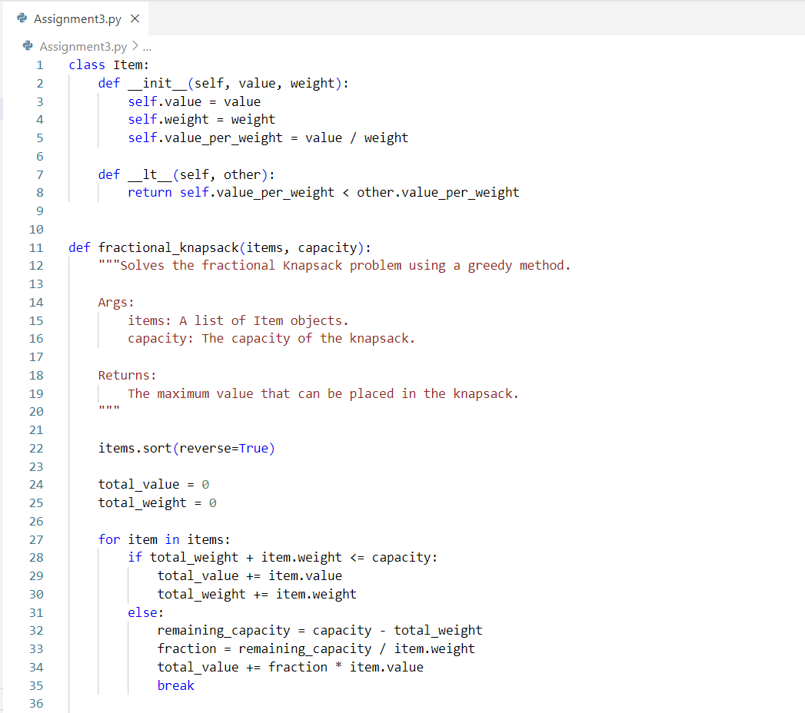

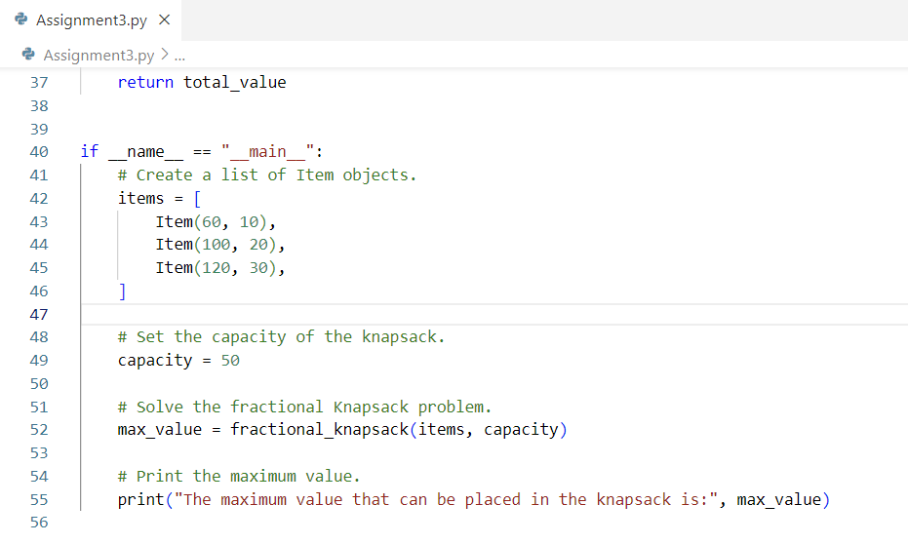

Output:

